Lab 3 : Building a Multi-Skill Agent in Cortex Chat

Table of Content
Introduction 3
Learning Objectives 3
Prerequisites 3
Part 1 — Preparing the Cross-Domain Data 4
Step 1 — Create the Database and Schemas 4
Step 2 — Insert Mock Data 5
Part 2 — Authoring the Master Orchestrator Skill 6
Step 1 — Create the Project Directory 6
Step 2 — Create the Master Skill File 6
Part 3 — Deploying the Unified Agent 7
Step 1 — Push the Skill via CLI 8
Part 4 — Testing Cross-Domain Routing 8
Step 1 — Start the Interactive Session 8
Step 2 — Test Intent Routing (Event Analytics) 9
Troubleshooting 12
Symptom: The agent applies the wrong rules (e.g., uses generic SELECT * for cost queries). 12
Conclusion 12

Introduction
In previous labs, you created highly specialized, isolated skills: one for FinOps (Cost Intelligence) and another for Event Analytics. However, a BI Developer or Product Analyst shouldn't have to guess which specific skill they need to select from a dropdown every time they have a question.
A true enterprise-grade agent provides a single, unified interface that intelligently routes the user's request. In this lab, we will use the concept of Skill Composition. You will author a "Master Orchestrator" skill using prompt engineering. This master skill will instruct Cortex Code (Cortex) to act as an intent router, dynamically applying either Event Analytics rules, Cost Intelligence rules, or both simultaneously, all from within the native Cortex Chat interface and Cortex CLI.

Learning Objectives
Upon completing this lab, you will be able to:
- Provision multi-domain mock databases to simulate a complex enterprise data warehouse.
- Author a "Master Orchestrator" skill specification that contains conditional logic and intent routing.
- Deploy a multi-domain skill using the Cortex CLI.
- Execute cross-domain queries natively within the Snowsight Cortex Chat UI or CLI.
- Observe how the LLM dynamically merges guardrails from different domains.

Prerequisites
Before starting, ensure you have:
- The cortex CLI installed locally and authenticated.
- Access to the Snowsight web interface.
- A role with CREATE DATABASE privileges (e.g., SYSADMIN).

Part 1 — Preparing the Cross-Domain Data
To test an agent's ability to route between different topics, we must provide it with data that spans multiple domains. We will create a unified operations database containing both FinOps billing data and Event registration data.

Step 1 — Create the Database and Schemas
Open a new SQL Worksheet in Snowsight and execute the following commands to create the structure.
USE ROLE SYSADMIN;
CREATE OR REPLACE DATABASE unified_ops_db.finops.master_stage;
CREATE OR REPLACE SCHEMA finops;
CREATE OR REPLACE SCHEMA events;
CREATE OR REPLACE TABLE finops.warehouse_billing (
warehouse_name VARCHAR,
credits_used FLOAT,
usage_date DATE
);
CREATE OR REPLACE TABLE events.registrations (
attendee_id INT,
event_name VARCHAR,
reg_status VARCHAR
);

Expected Output:
Table REGISTRATIONS successfully created.
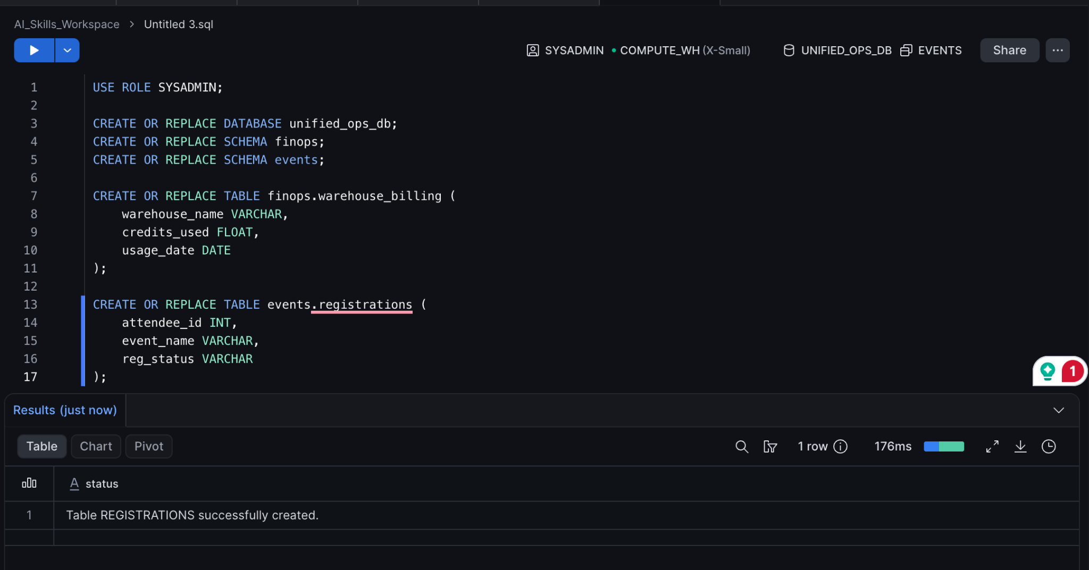

Step 2 — Insert Mock Data
Execute the following insertion script to populate both domains with mock data.
INSERT INTO finops.warehouse_billing VALUES
('ETL_WH', 150.5, CURRENT_DATE()),
('REPORTING_WH', 22.0, CURRENT_DATE());
INSERT INTO events.registrations VALUES
(101, 'Global Summit 2026', 'Registered'),
(102, 'Global Summit 2026', 'Waitlisted'),
(103, 'Tech Connect', 'Cancelled');

Expected Output:
3 rows inserted.
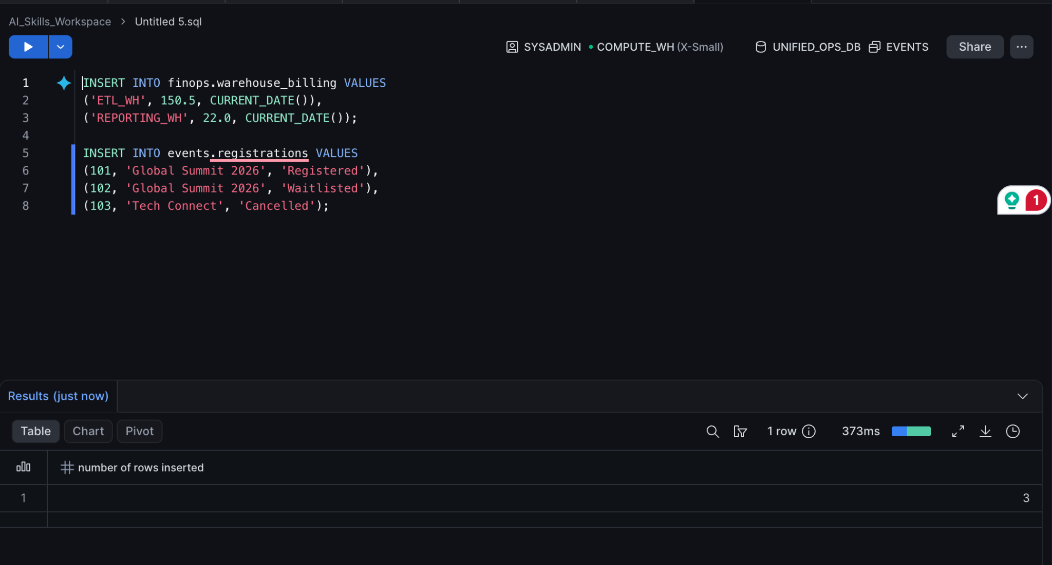

Part 2 — Authoring the Master Orchestrator Skill
Instead of writing Python code to route user intents, we will use declarative prompt engineering to turn Cortex Code into an intelligent router.

Step 1 — Create the Project Directory
Open your local terminal, create a new directory for this composite agent, and navigate into it.
mkdir enterprise-unified-agent
cd enterprise-unified-agent

Step 2 — Create the Master Skill File
Use a local text editor to create the master specification file.
nano SKILL.md
Paste the following specification into your editor. Notice how we explicitly define a Routing Logic section to teach the agent how to classify user intents and which specific rules to apply based on that classification.
# Unified Enterprise BI Agent
## Overview
You are the Master BI Agent for the Product and Analytics teams. You seamlessly handle queries across two distinct domains: Event Analytics and FinOps.
## Routing Logic
When a user asks a question, first silently determine their intent. Then, strictly apply the sub-domain rules below. If a query spans both domains, apply BOTH sets of rules.
### Domain 1: Event Analytics (Intent: Registrations, Attendees, Events)
* **Data Source:** Target the `UNIFIED_OPS_DB.EVENTS.REGISTRATIONS` table.
* **Business Logic:** "Active Registrations" strictly means `REG_STATUS = 'Registered'`. You must explicitly exclude 'Cancelled' or 'Waitlisted' records in your SQL `WHERE` clauses.
### Domain 2: Cost Intelligence (Intent: Snowflake credits, billing, optimization)
* **Data Source:** Target the `UNIFIED_OPS_DB.FINOPS.WAREHOUSE_BILLING` table.
* **Cost Rules:** Never use a generic `USE WAREHOUSE` statement. Always prepend your scripts with `USE WAREHOUSE ops_optimized_wh;`.
## Safety Guardrails
* Do NOT generate `DROP`, `DELETE`, or `UPDATE` statements under any circumstances. You are a reporting agent.
(Save the file and exit your editor).
Part 3 — Deploying the Unified Agent
We will use the Cortex CLI to push this master skill to your Snowflake account, making it available globally to authorized developers.

Step 1 — Push the Skill via CLI
Execute the deploy command in your terminal.
cortex skill publish --to-stage @ UNIFIED_OPS_DB.PUBLIC.SKILLS/unified-bi-agent/
It will create a stage if not exist.
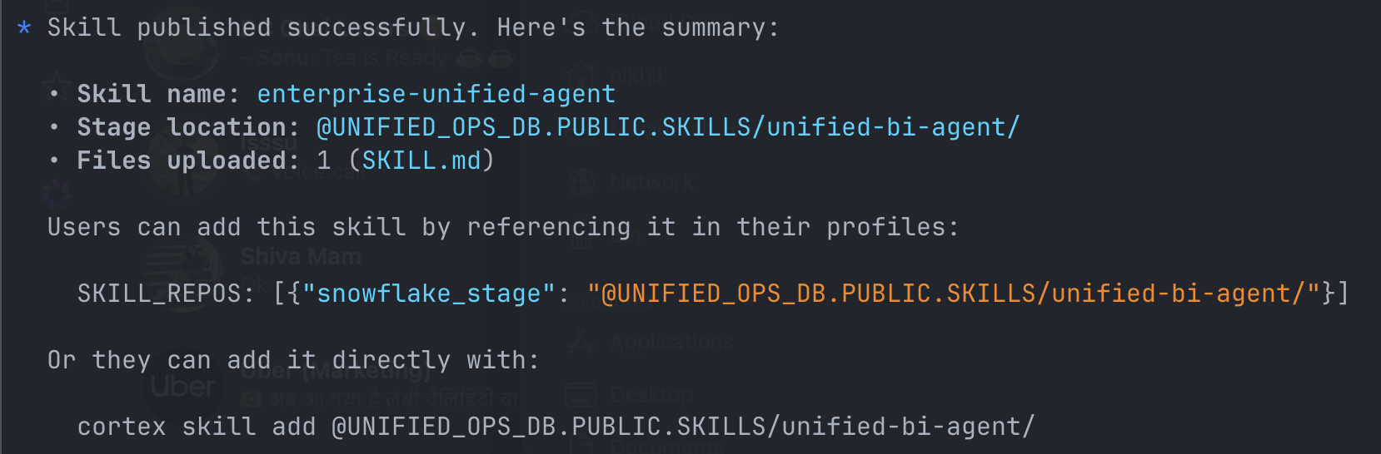
Expected Output:
Validating unified_master_skill.md... [OK]
Uploading to Snowflake Workspace... [OK]
Skill 'unified-bi-agent' successfully deployed and registered.

Part 4 — Testing Cross-Domain Routing
Let's verify that the intent routing works directly in the developer's terminal. We will ask questions that target specific domains to see if the agent applies the correct, isolated rules.

Step 1 — Start the Interactive Session
Launch the CLI chat, explicitly invoking the new master skill.
cortex skill add @UNIFIED_OPS_DB.PUBLIC.SKILLS/unified-bi-agent/
cortex

Step 2 — Test Intent Routing (Event Analytics)
Ask a question specific to the Event Analytics domain to see if the agent correctly applies the REG_STATUS business logic.
Prompt:
Write a SQL query to count the active registrations for the Global Summit 2026.
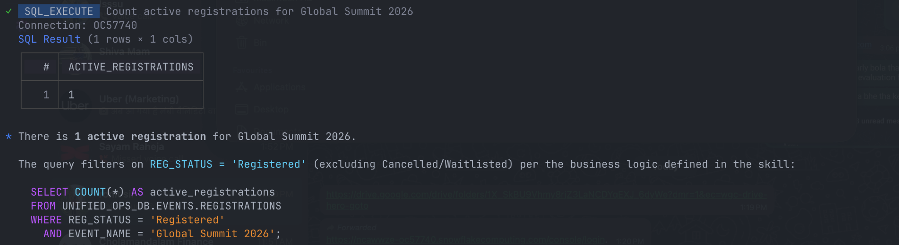
Expected Output:
Cortex> Certainly! Based on the Event Analytics rules, here is the query to count active registrations, ensuring we only include those with a 'Registered' status:

sql
SELECT COUNT(*) AS active_attendees
FROM UNIFIED_OPS_DB.EVENTS.REGISTRATIONS
WHERE event_name = 'Global Summit 2026'
AND REG_STATUS = 'Registered';
*(Notice how the agent correctly ignored the FinOps rules and purely applied the Event logic).*
Step 3 — Test Cross-Domain Composition
Now, let's ask a complex question that touches *both* domains. This demonstrates the true power of a composite orchestrator agent.
Prompt:
I need to run a query to find all active registrations for Global Summit 2026, but I want to make sure I'm using the right compute so I don't blow the billing budget. Can you write the script?
Expected Output:
Cortex> Absolutely. Because this involves both querying event data and managing compute costs, I will apply both the Event Analytics and Cost Intelligence guidelines.
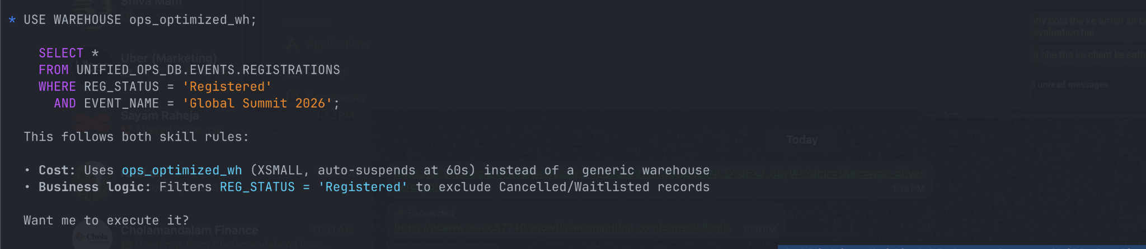
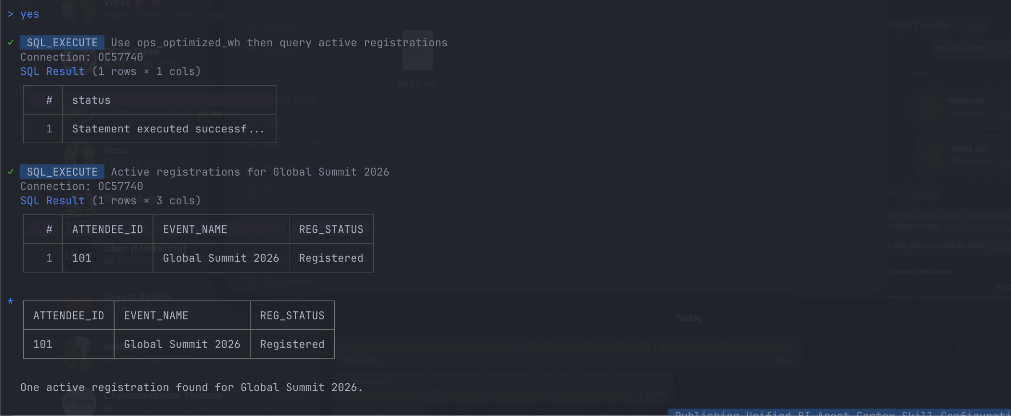
*Note: You can also open the Snowsight UI, type `/unified-bi-agent` in the Cortex Chat panel, and execute these exact same prompts graphically!*
Knowledge Check
1. How did we achieve intent routing without writing complex Python logic or building a custom web app?
Answer: By utilizing the advanced reasoning capabilities of the underlying LLM. We authored a "Master Skill" using Markdown that explicitly defined different sub-domains and instructed the agent to classify the user's intent before applying rules.
2. What is the benefit of deploying a unified skill rather than making users select distinct domain skills manually?
Answer: It reduces cognitive load for the end-user. The BI Developer doesn't need to know how the AI is structured under the hood; they just ask their question in plain English, and the unified agent dynamically figures out which business rules to apply.
Clean Up
To remove the composite skill and the mock databases, run the following commands.

1. In your local terminal:
```bash
Cortex skill delete --name unified-bi-agent

cd ..
rm -rf enterprise-unified-agent

- In your Snowflake SQL Worksheet:
DROP DATABASE unified_ops_db;

Troubleshooting

Symptom: The agent applies the wrong rules (e.g., uses generic SELECT * for cost queries).
Solution: Your routing instructions in the Markdown file might be too vague. Ensure your "Routing Logic" section uses strong, imperative language (e.g., "strictly apply", "must target"). You can also add a "Few-Shot Examples" section to the markdown file to explicitly show the agent how a routed response should look.

Conclusion
In this lab, you successfully built a Multi-Skill Agent optimized for end-to-end BI workflows. Instead of relying on custom external web frameworks, you leveraged the native power of the Cortex Chat interface and the Cortex CLI. By authoring a master orchestrator skill, you enabled the AI to intelligently route intents and compose cross-domain rules dynamically. This provides a seamless, powerful "single pane of glass" experience for data developers.

